Lab 1
  - Adnane AIT MAGOURT

Github repository: https://github.com/adnanemagourt/lab-mlops-1

Flask Lab

Example 1:

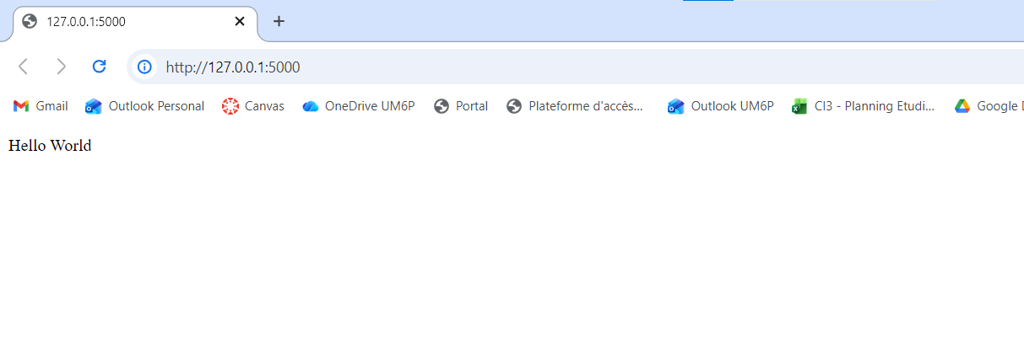
"Hello World" rendered in the web browser

Example 2:

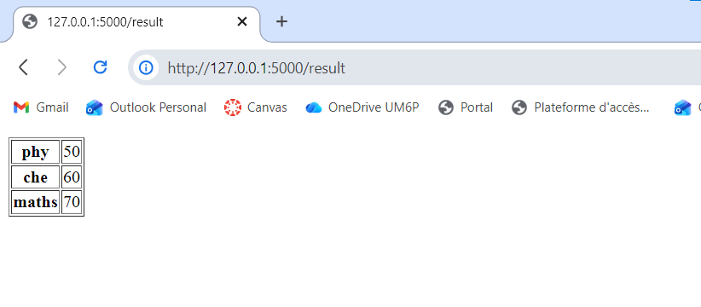
The Python dictionary containing subjects and their corresponding marks are rendered in the web page

Example 3:

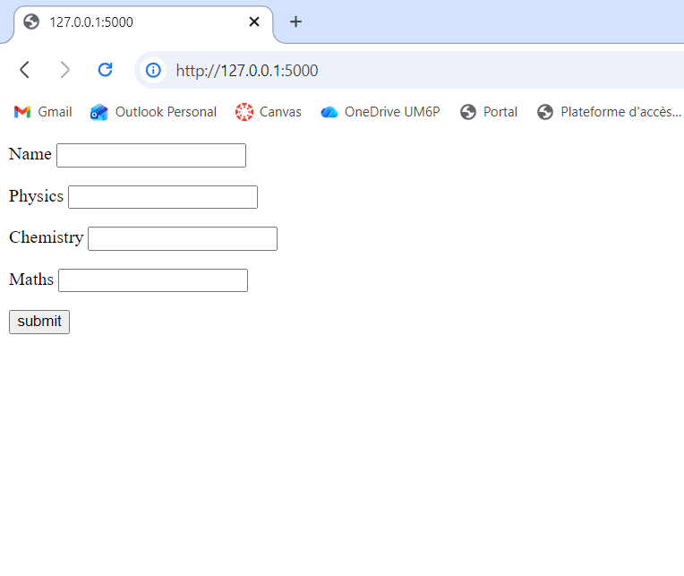
HTML form designed to capture a name and marks for Physics, Chemistry, and Maths.
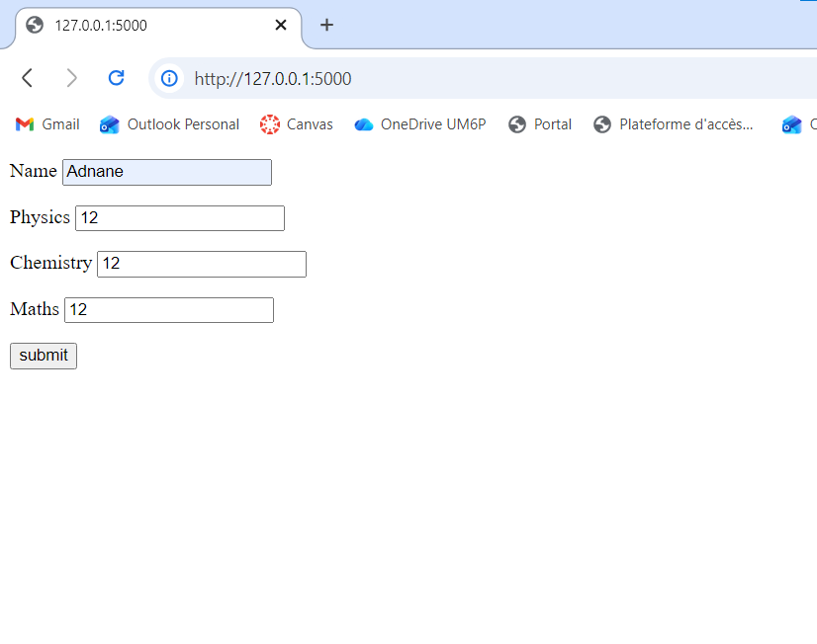
We fill the form

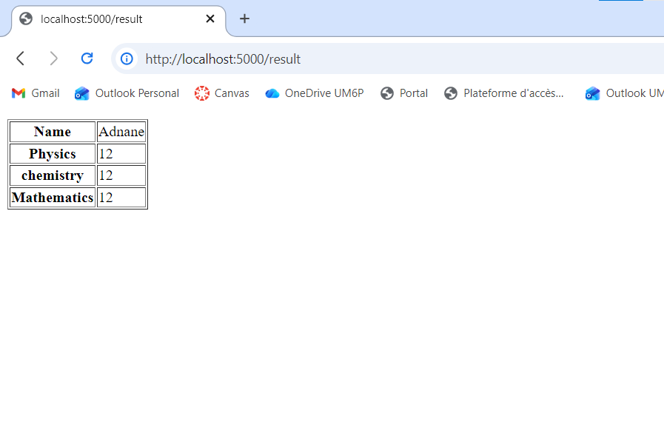
/result page, where the data submitted from the form has been processed by the Flask backend and is rendered back to the user in a table format.

Furniture prediction:

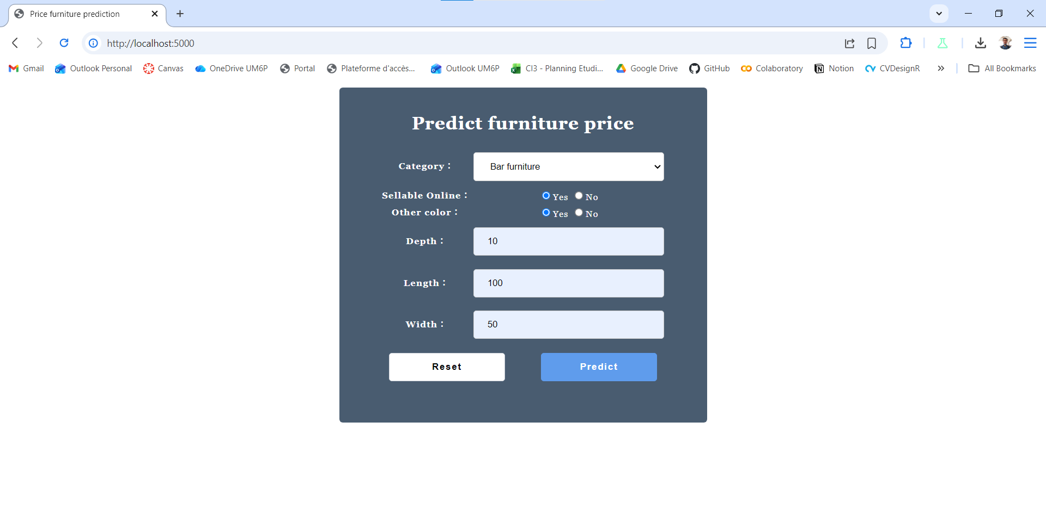

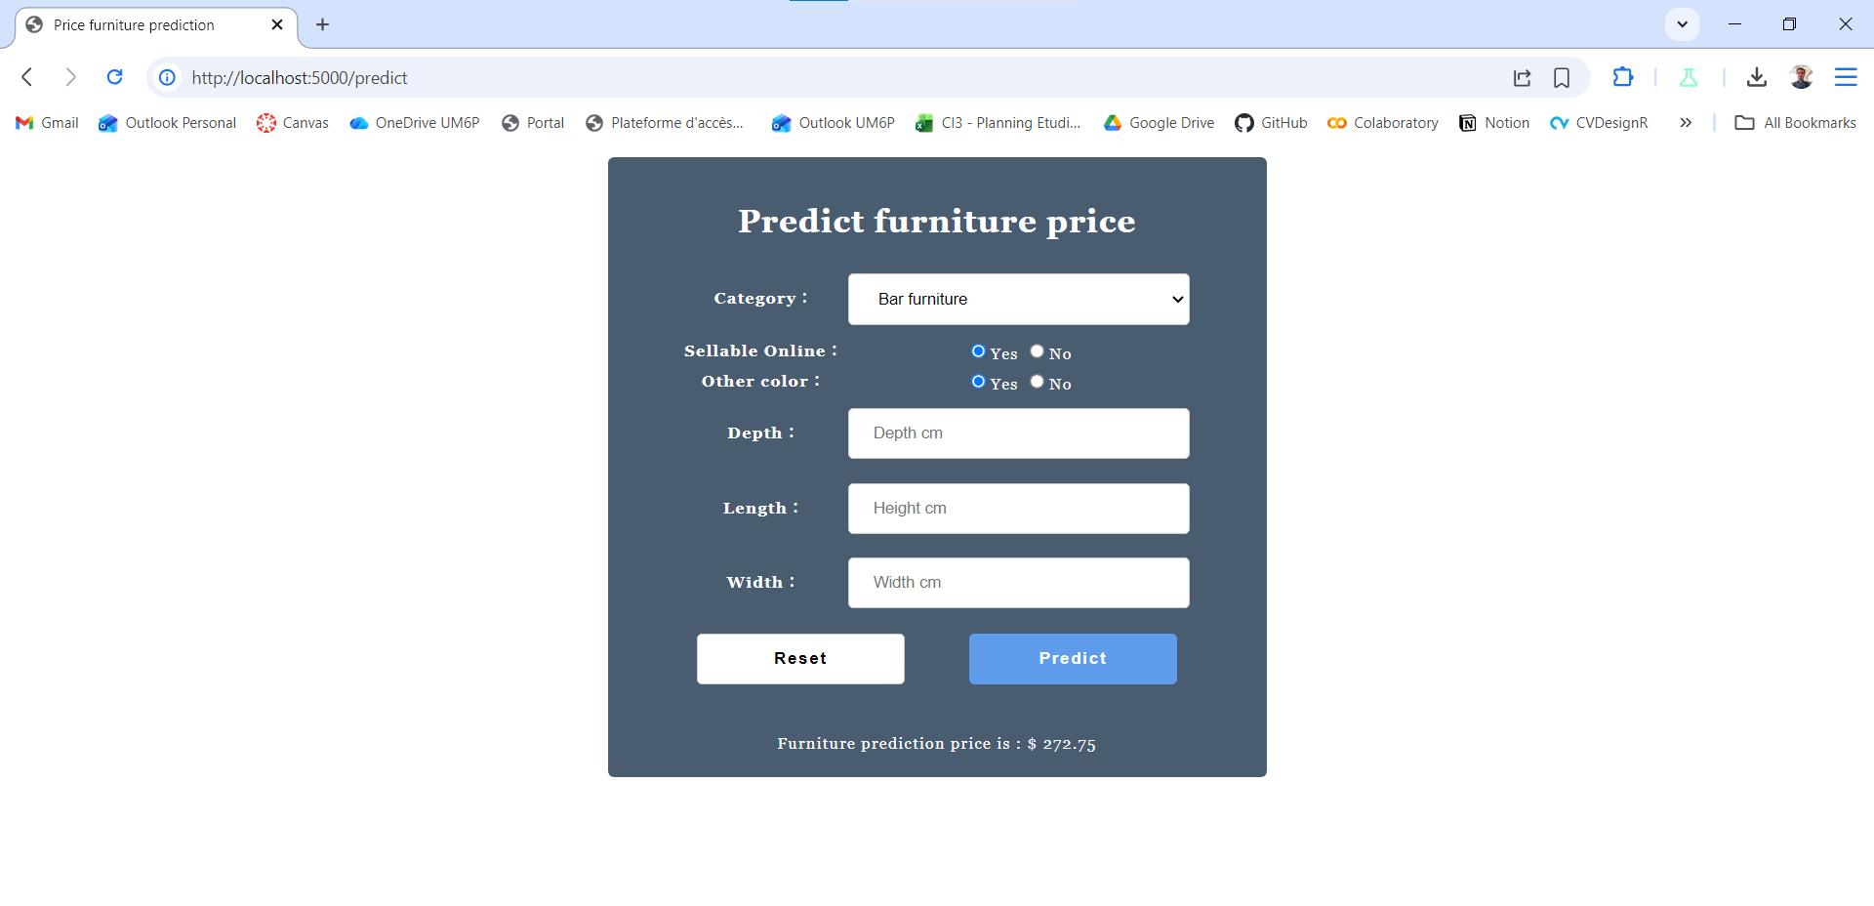
the result after we submits the form. The features are sent to the Flask backend, processed by the loaded machine learning model, and the final predicted price of "$ 272.75" is displayed.

Assignment:

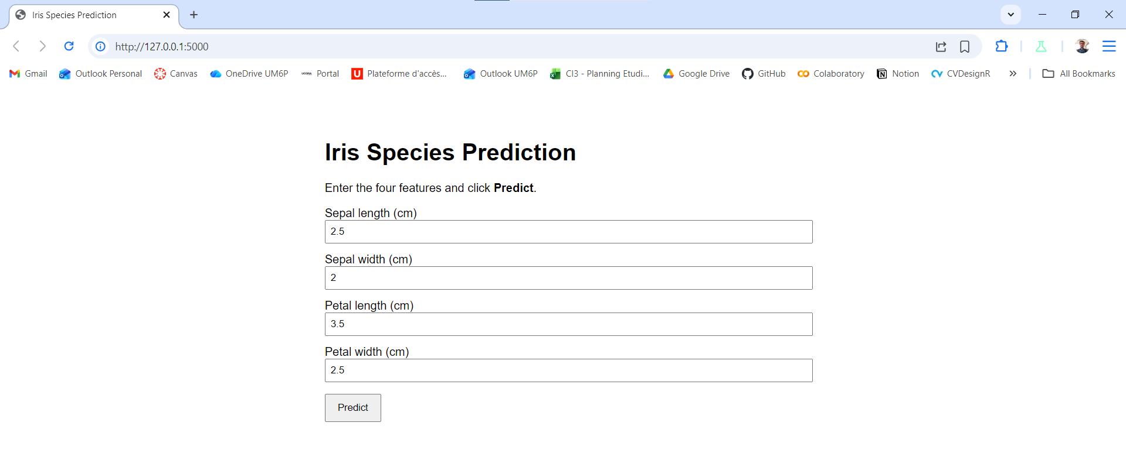

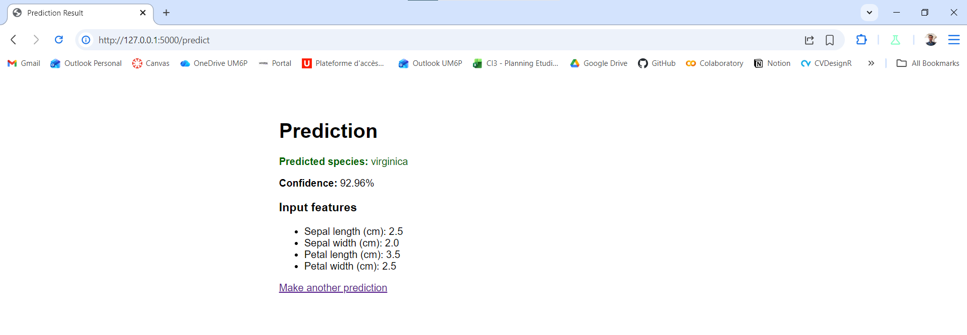

he prediction result after submitting the features

Python Libraries FastAPI

- Introduction to Pytest

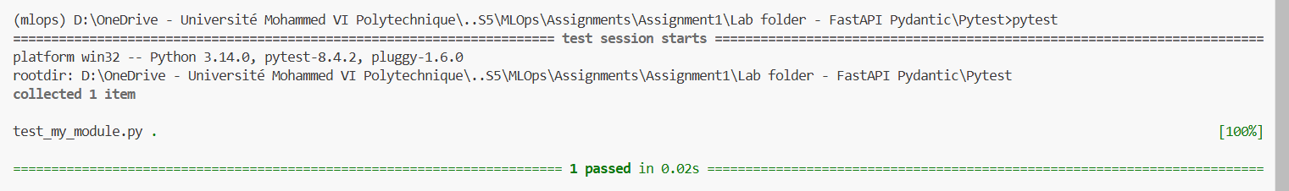
The output "1 passed" indicates that the initial test for the square function ran without any errors.

After changing value 4 to 7:
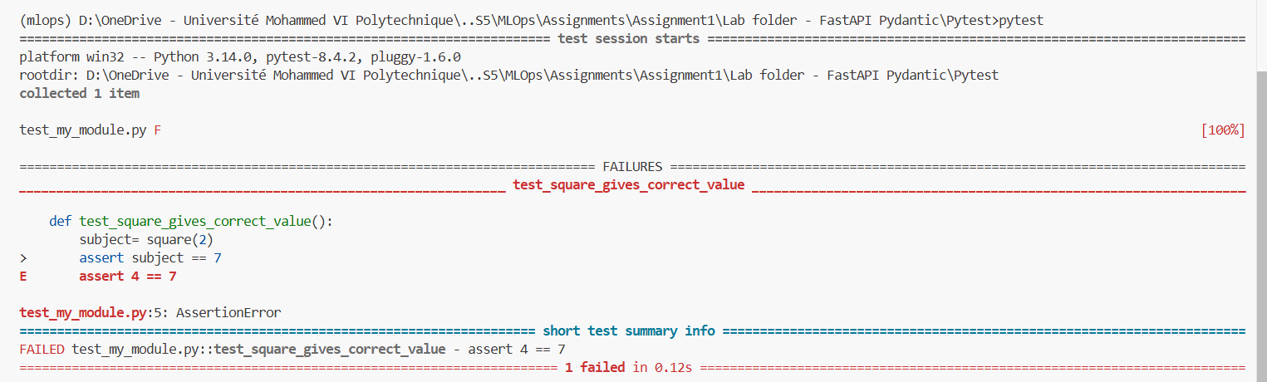
The assertion in the test code was intentionally changed to an incorrect value (assert 4 == 7), and the screenshot shows the resulting AssertionError, which clearly indicates the point of failure.

After using fixture:
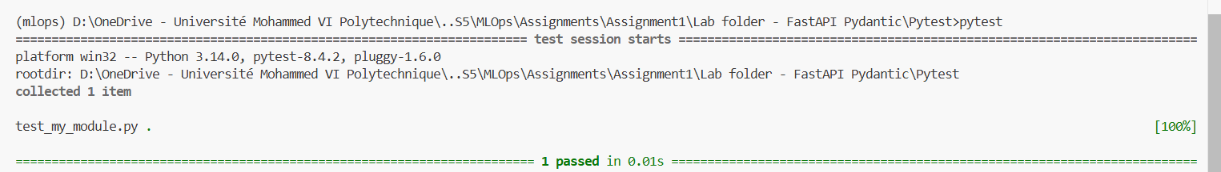
This screenshot shows the test passing again after the code was refactored to use a Pytest fixture.

After adding another test:
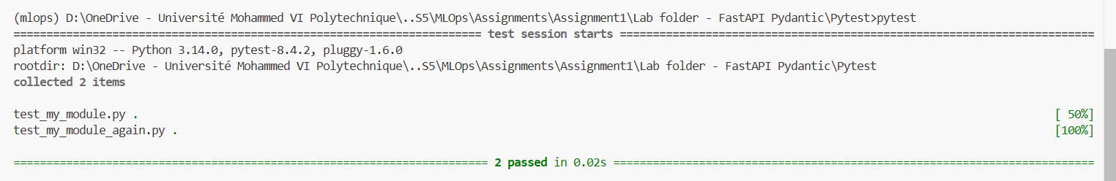
The terminal now reports that "2 passed," demonstrating Pytest's automatic discovery and execution of multiple test files

Using conftest.py:

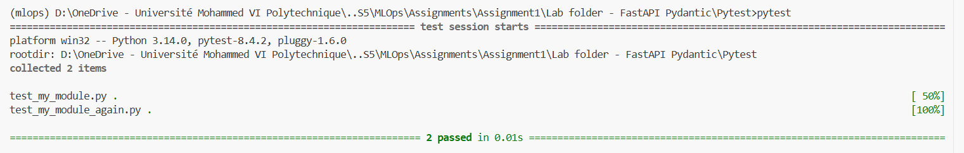
The tests are utilizing a shared fixture defined in a conftest.py file

Paramaterized test:

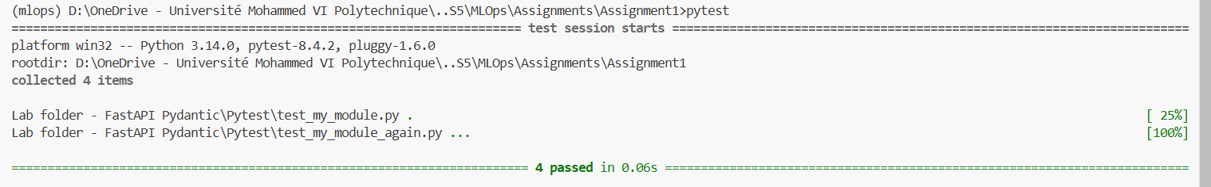
a single test function was executed multiple times with different inputs.

- Introduction to Pydantic
Example 1:
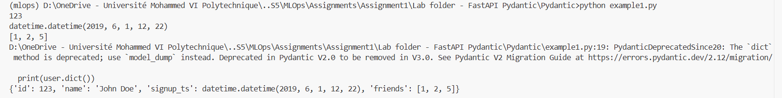
This converted types to pydantic types: id '123' → int 123, '5' → 5, signup_ts string → datetime

Example 2:
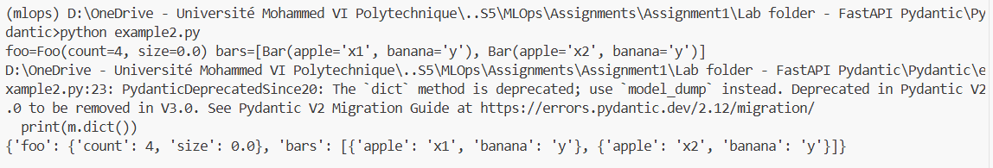

Validator:
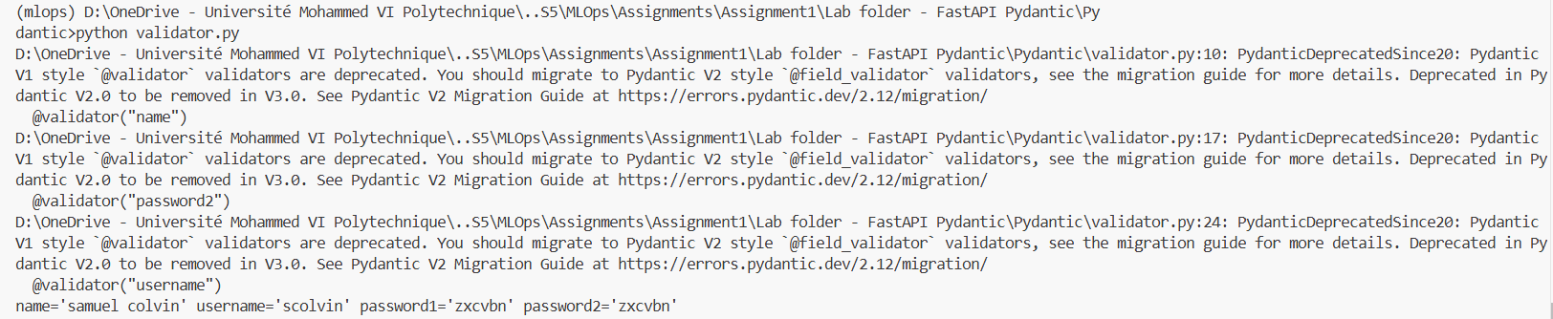
The code successfully creates a user instance

- Introduction à FastAPI

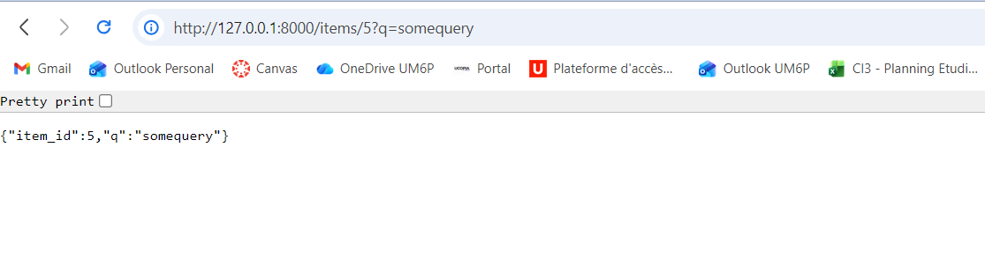

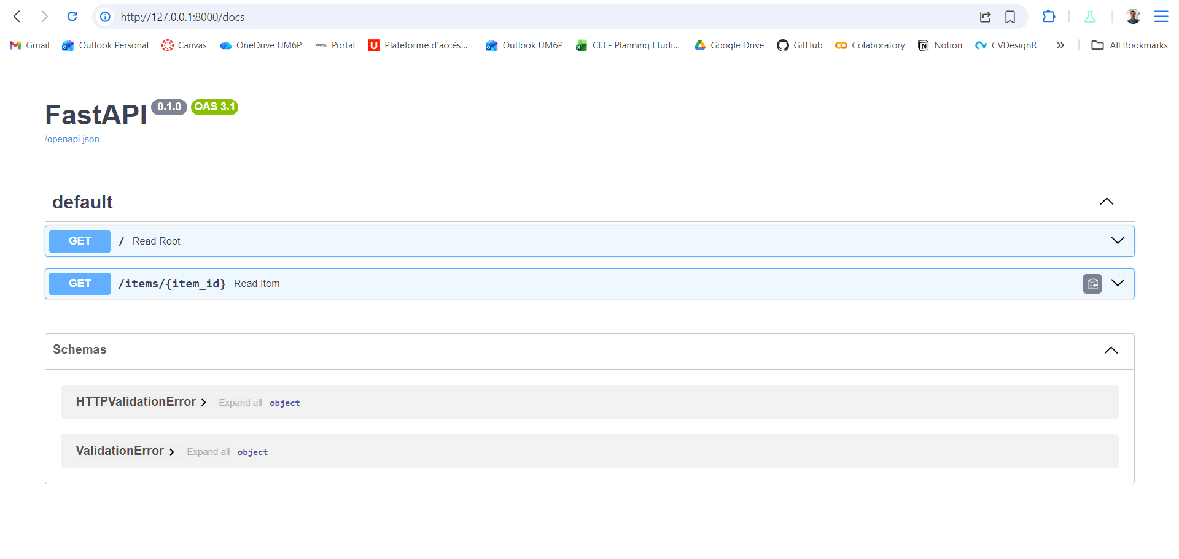

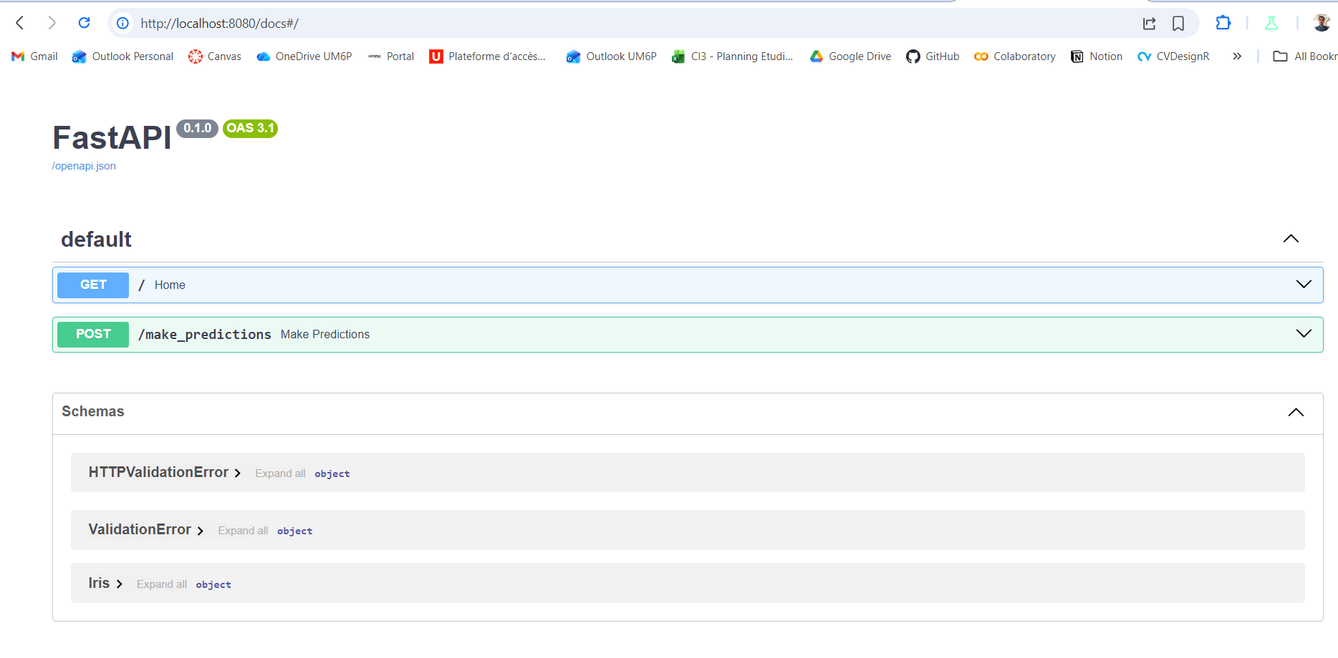

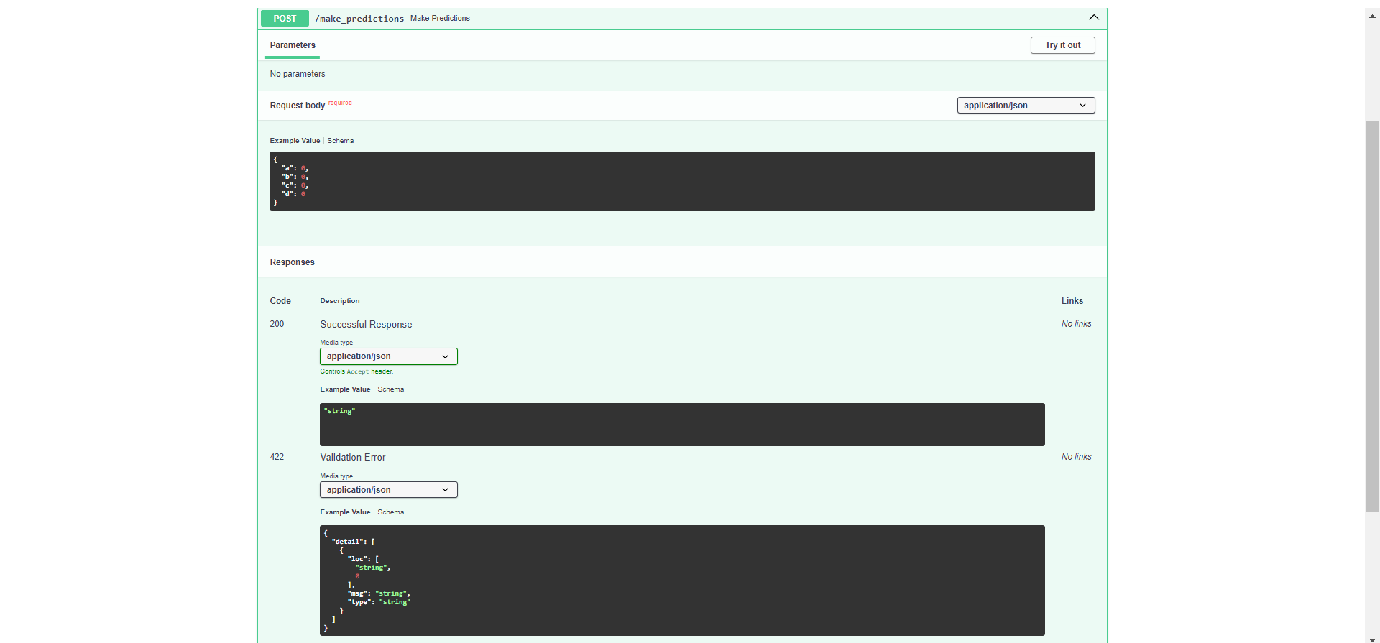

Todo:

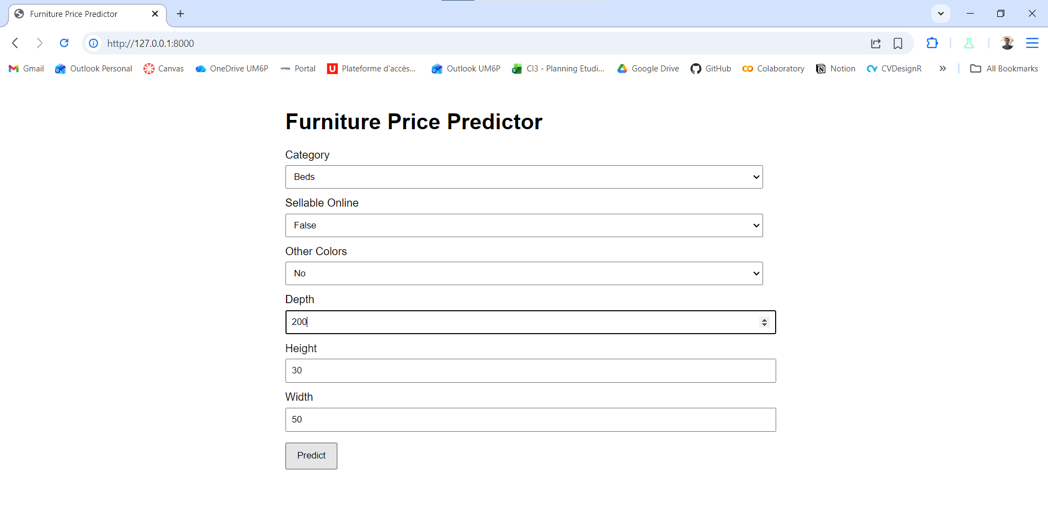

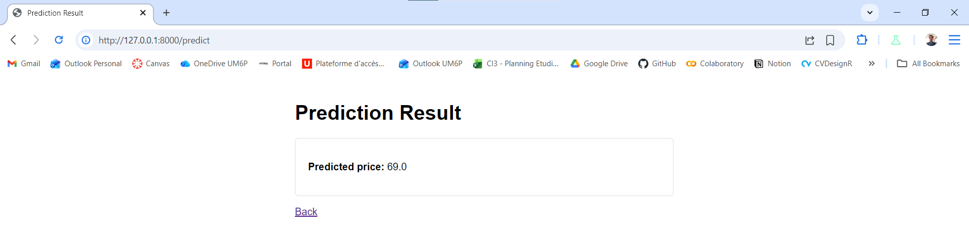

Using previous model and dataset:
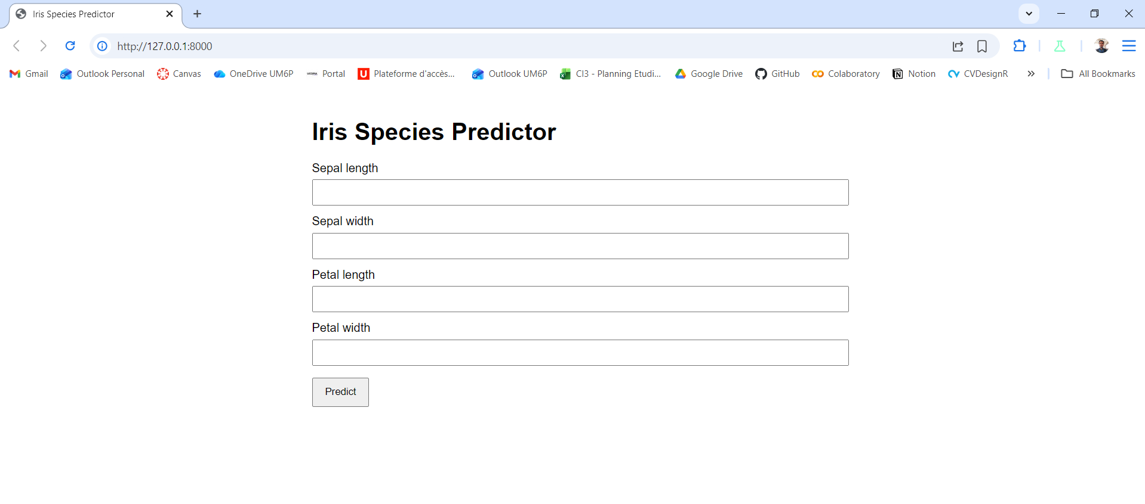

We made the same web interface

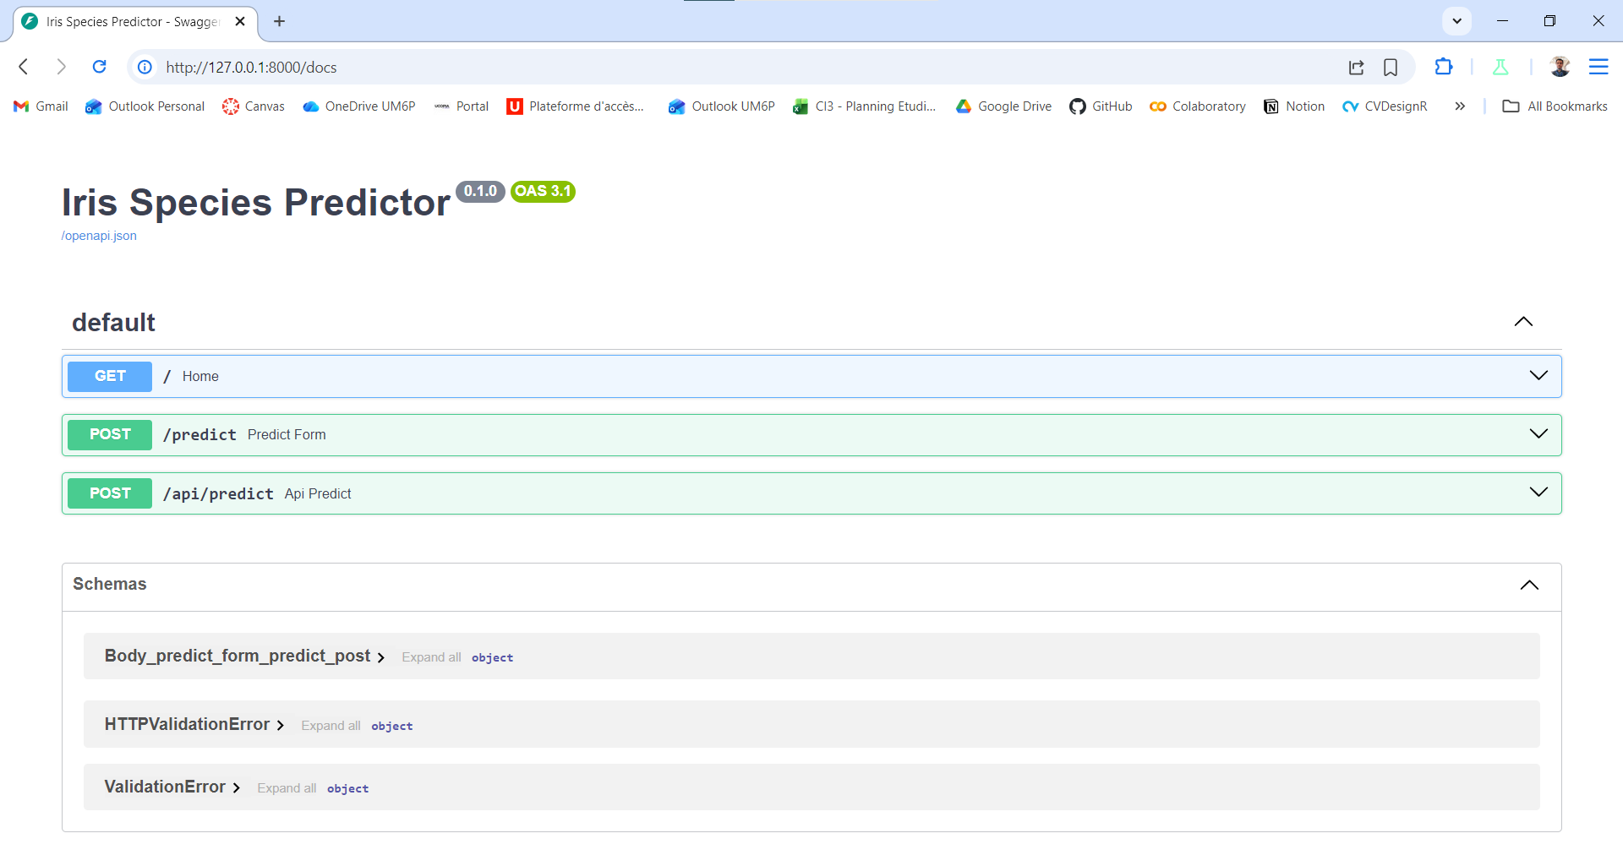here are the api endpoints

